**COMP 3981: Project Description (Part #1)**

# Problem Formulation and Graphical User Interface (GUI) Implementation

## State Representation:

Black Marbles at $[x_{1},y_{1}; x_{2},y_{2}; x_{3},y_{3};…. ….. … x_{14},y_{14}.]$ 8

White Marbles at $[x_{1},y_{1}; x_{2},y_{2}; x_{3},y_{3};…. ….. … x_{14},y_{14}.]$

## Initial State: (For visuals, please see end of document)

|  |  |  |
| --- | --- | --- |
|  | Black Marbles [location, marbles lost] | White Marbles [location, marbles lost] |
| **Standard Formation** | $$[G3, G4, G5, H1, H2, H3, H4$$ $$H5, H6, I1, I2, I3, I4, I5 ;0 lost ]$$ | $$[A5,A6,A7,A8,A9,B4,B5$$ $$B6,B7,B8,B9,C5,C6,C7 ;0 lost]$$ |
| **Belgian Daisy Formation** | $$[G2, G3, H1, H2, H3, I1, I2,$$ $$A8, A9, B7, B8, B9, C7, C8 ;0 lost ]$$ | $$[A5, A6, B4, B5 ,B6, C4, C5$$ $$G5, G6, H4, H5, H6, I4, I5 ;0 lost]$$ |
| **German Daisy Formation** | $$[F2,F3,G1,G2,G3,H1,H2$$ $$B8,B9,C7,C8,C9,D7,D8 ;0 lost]$$ | $$[B4,B5,C3,C4,C5,D3,D4$$ $$F6,F7,G5,G6,G7,H5,H6;0 lost]$$ |

## Goal Test:

Black Marbles: $[x_{1},y_{1}; x_{2},y_{2}; x_{3},y_{3};…. ….. … x_{8},y_{8} ;6 lost]$

or

White Marbles: $[x_{1},y_{1}; x_{2},y_{2}; x_{3},y_{3};…. ….. … x_{8},y_{8} ;6 lost]$

## Actions (For visuals please see end of document

|  |  |  |  |
| --- | --- | --- | --- |
| #Marbles | Alignment of marbles | Actions (Given current state $x_{n},y_{n}$) | Resulting State |
| 1 | N/A | $$Move towards V_{1}$$ | $${marble at (x-1}_{n},y_{n})$$ |
| 1 | N/A | $$Move towards V_{2}$$ | $${marble at (x-1}_{n},{y+1}_{n})$$ |
| 1 | N/A | $$Move towards V_{3}$$ | $${marble at (x}_{n},{y+1}_{n})$$ |
| 1 | N/A | $$Move towards V_{4}$$ | $${marble at (x+1}_{n},y_{n})$$ |
| 1 | N/A | $$Move towards V_{5}$$ | $${marble at (x+1}_{n},{y-1}_{n})$$ |
| 1 | N/A | $$Move towards V_{6}$$ | $${marble at (x}_{n},{y-1}_{n})$$ |
| 2 | Horizontal | $$Move broadside towards V_{1}$$ | $${marbles at (x-1}_{n},y_{n} ; {x-1}_{n},y_{n})$$ |
| 2 | Vertical | $$Move inline towards V_{1}$$ | $${marbles at (x-1}_{n},y_{n} ; {x-1}_{n},y_{n})$$ |
| 2 | Horizontal | $$Move broadside towards V_{2}$$ | $${marbles at (x-1}_{n},{y+1}_{n} ; {x-1}_{n},{y+1}_{n})$$ |
| 2 | Vertical | $$Move inline towards V_{2}$$ | $${marbles at (x-1}_{n},{y+1}_{n} ; {x-1}_{n},{y+1}_{n})$$ |
| 2 | Horizontal | $$Move inline towards V_{3}$$ | $${marbles at (x}_{n},{y+1}_{n} ; x_{n},{y+1}_{n})$$ |
| 2 | Vertical | $$Move broadside towards V_{3}$$ | $${marbles at (x}_{n},{y+1}_{n} ; x_{n},{y+1}_{n})$$ |
| 2 | Horizontal | $$Move broadside towards V_{4}$$ | $${marbles at (x+1}_{n},y_{n} ; {x+1}_{n},y_{n})$$ |
| 2 | Vertical | $$Move inline towards V_{4}$$ | $${marbles at (x+1}_{n},y_{n} ; {x+1}_{n},y_{n})$$ |
| 2 | Horizontal | $$Move broadside towards V_{5}$$ | $${marbles at (x+1}_{n},{y-1}_{n} ; {x+1}_{n},{y-1}_{n})$$ |
| 2 | Vertical | $$Move inline towards V_{5}$$ | $${marbles at (x+1}_{n},{y-1}_{n} ; {x+1}_{n},{y-1}_{n})$$ |
| 2 | Horizontal | $$Move inline towards V_{6}$$ | $${marbles at (x}_{n},{y-1}_{n} ; x_{n},{y-1}_{n})$$ |
| 2 | Horizontal | $$Move broadside towards V_{6}$$ | $${marbles at (x}_{n},{y-1}_{n} ; x_{n},{y-1}_{n})$$ |
| 3 | Horizontal | $$Move broadside towards V_{1}$$ | $${marbles at (x-1}_{n},y_{n} ; {x-1}_{n},y_{n} ; {x-1}_{n},y_{n})$$ |
| 3 | Vertical | $$Move inline towards V_{1}$$ | $${marbles at (x-1}_{n},y_{n} ; {x-1}_{n},y_{n} ; ; {x-1}_{n},y_{n})$$ |
| 3 | Horizontal | $$Move broadside towards V_{2}$$ | $${marbles at (x-1}_{n},{y+1}_{n} ; {x-1}_{n},{y+1}_{n}, ; {x-1}_{n},{y+1}_{n})$$ |
| 3 | Vertical | $$Move inline towards V_{2}$$ | $${marbles at (x-1}_{n},{y+1}_{n} ; {x-1}_{n},{y+1}_{n} ; {x-1}_{n},{y+1}_{n})$$ |
| 3 | Horizontal | $$Move inline towards V_{3}$$ | $${marbles at (x}_{n},{y+1}_{n} ; x_{n},{y+1}_{n} ; x_{n},{y+1}_{n})$$ |
| 3 | Vertical | $$Move broadside towards V_{3}$$ | $${marbles at (x}_{n},{y+1}_{n} ; x_{n},{y+1}_{n} ; x_{n},{y+1}_{n})$$ |
| 3 | Horizontal | $$Move broadside towards V_{4}$$ | $${marbles at (x+1}_{n},y_{n} ; {x+1}_{n},y_{n} ; {x+1}_{n},y_{n})$$ |
| 3 | Vertical | $$Move inline towards V_{4}$$ | $${marbles at (x+1}_{n},y_{n} ; {x+1}_{n},y_{n} ; {x+1}_{n},y_{n})$$ |
| 3 | Horizontal | $$Move broadside towards V_{5}$$ | $${marbles at (x+1}_{n},{y-1}_{n} ; {x+1}_{n},{y-1}_{n} ; {x+1}_{n},{y-1}_{n})$$ |
| 3 | Vertical | $$Move inline towards V_{5}$$ | $${marbles at (x+1}_{n},{y-1}_{n} ; {x+1}_{n},{y-1}_{n} ; {x+1}_{n},{y-1}_{n})$$ |
| 3 | Horizontal | $$Move inline towards V_{6}$$ | $${marbles at (x}_{n},{y-1}_{n} ; x_{n},{y-1}_{n} ; x_{n},{y-1}_{n})$$ |
| 3 | Horizontal | $$Move broadside towards V_{6}$$ | $${marbles at (x}_{n},{y-1}_{n} ; x_{n},{y-1}_{n} ; x_{n},{y-1}_{n})$$ |

## Resources:

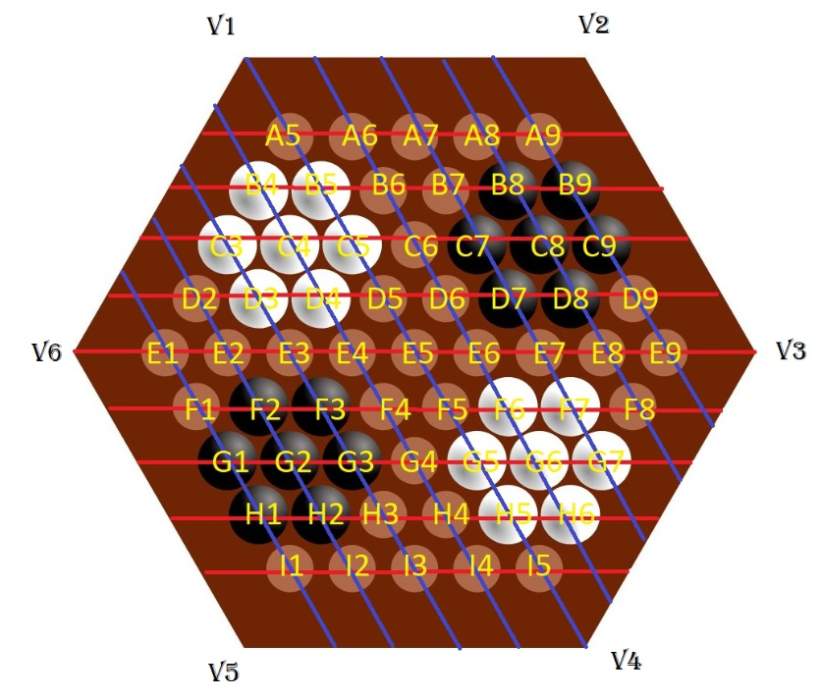

Figure - German Daisy layout with coordinates and vectors.

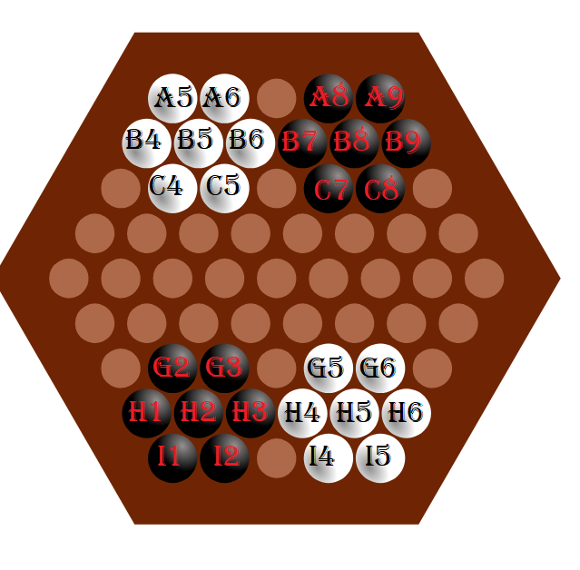

Figure - Belgian Daisy Layout with coordinates.

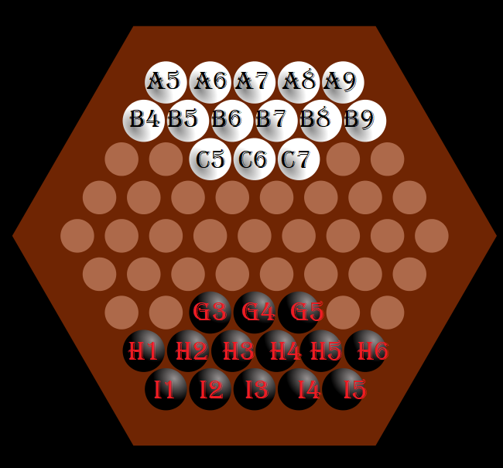

Figure - Standard Layout of the board with coordinates.